EXPERIMENT 7:

Create a simple cloud software application for Students Attendance System using any Cloud Service Provider to demonstrate SaaS include the necessary fields such as name of the students, course, present , Absent, course attendance, OD request, grade, attendance percentage, etc.

**AIM:**

To Create a simple cloud software application for students attendance system using any Cloud Service Provider to demonstrate SaaS.

**PROCEDURE:**

**step1:** Go to zoho.com.

**step 2:** Log into the zoho.com.

**step 3:** Select one application step.

**step4:** Enter application name as student attendance system.

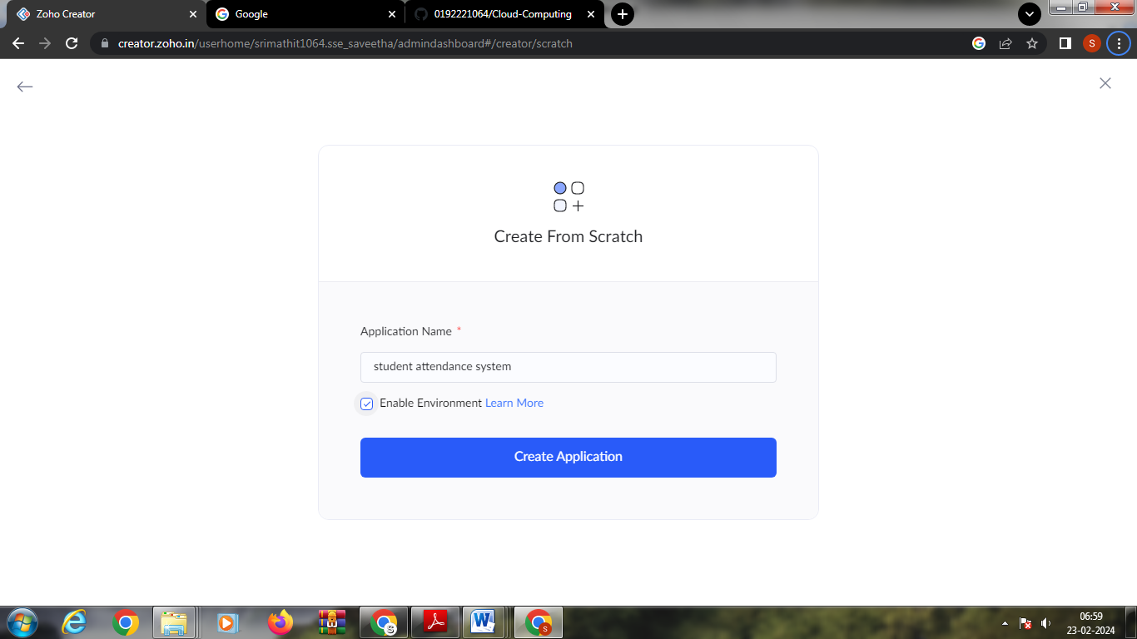

**step 5:** Created new application as student attendance system.

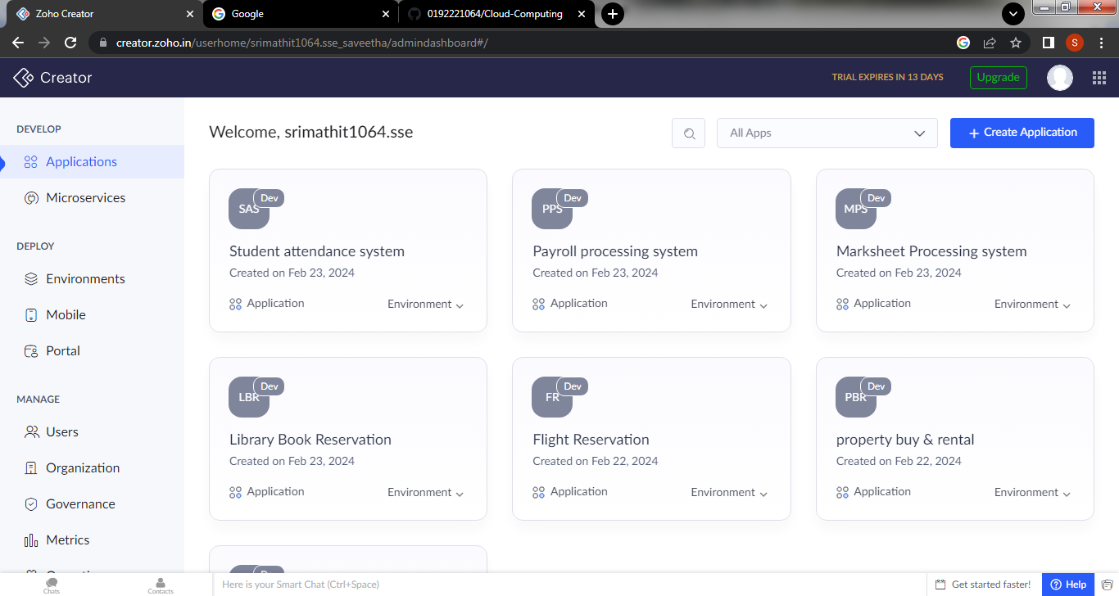

Step 6:create a new form for student details

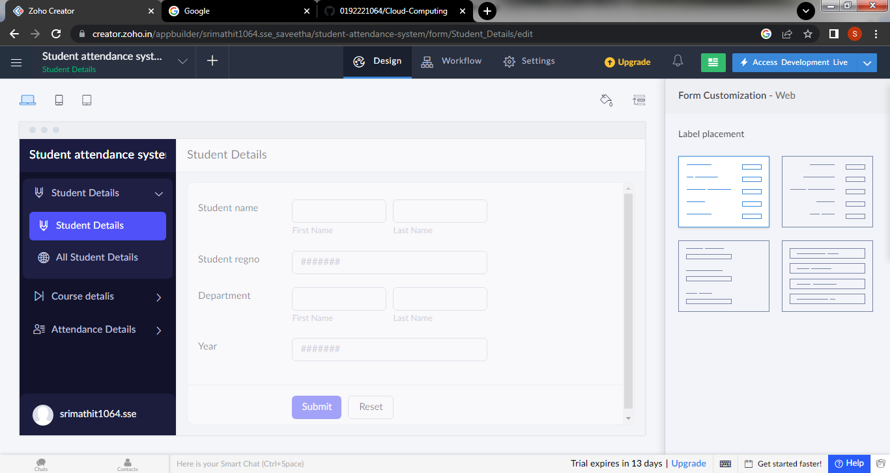

Step 7: create a second form for OD-Request

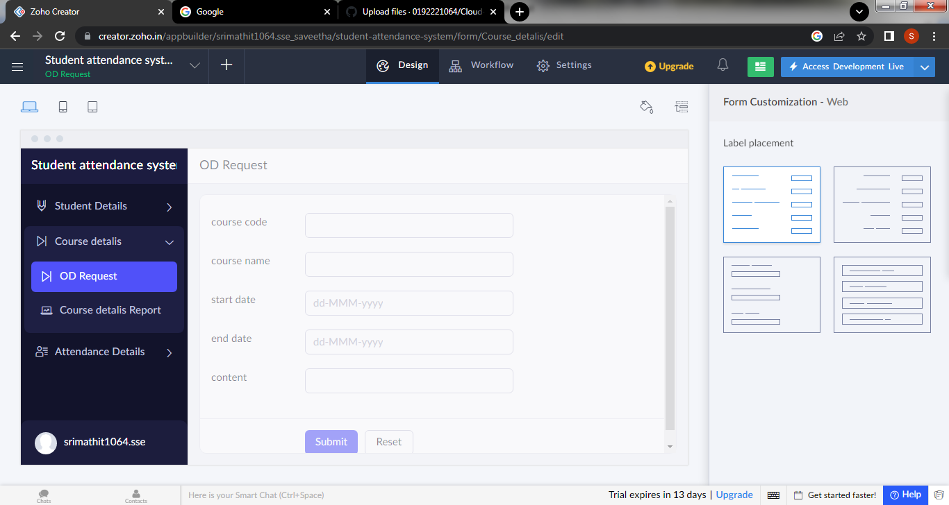

Step 8: Create a form for attendance details of the student.

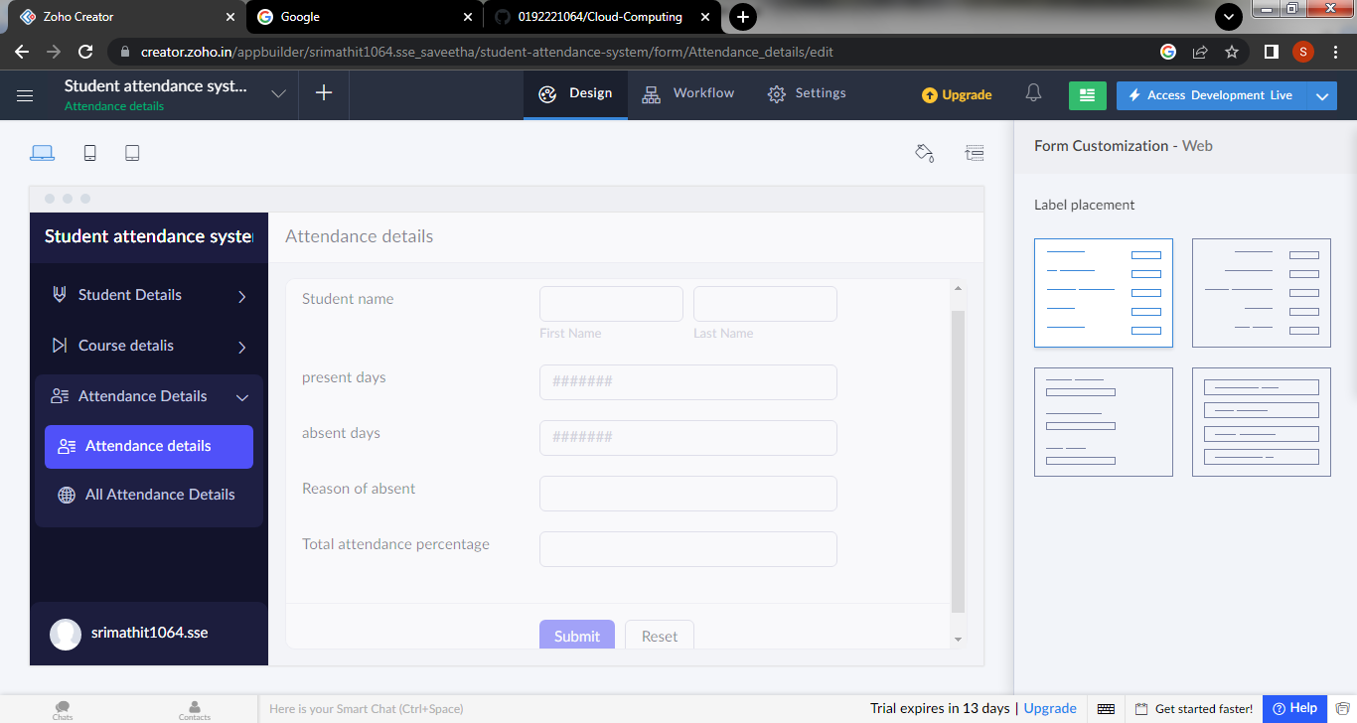

Step 9: click the access development to view the live output

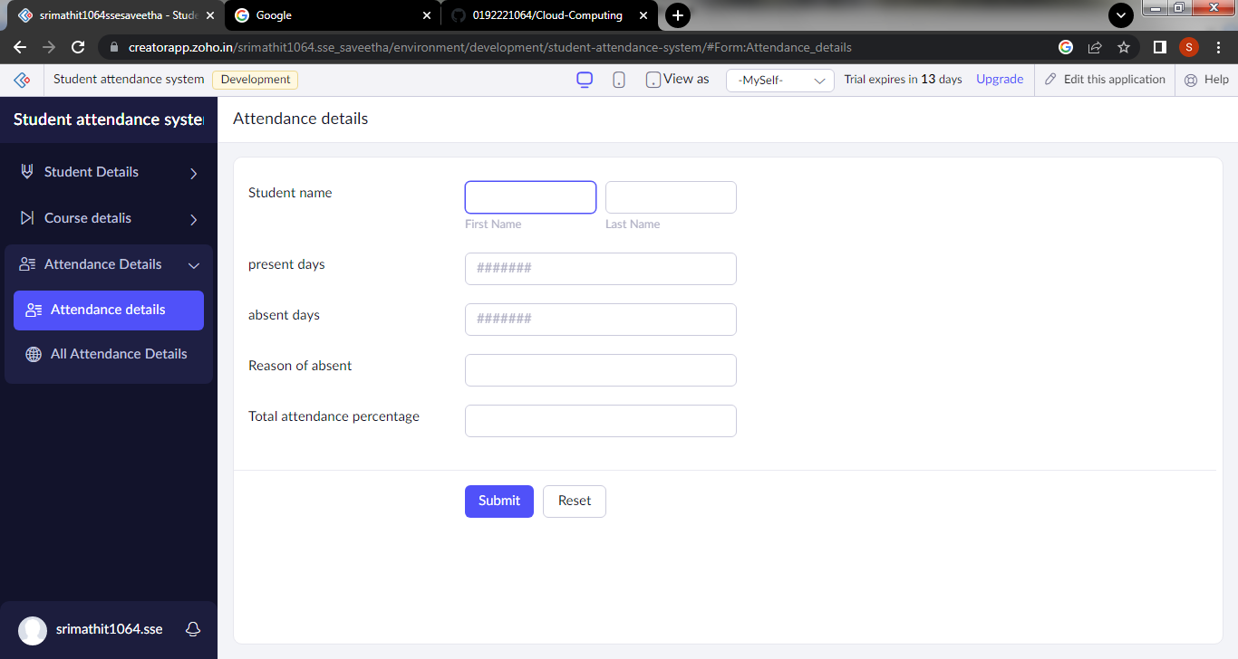

Step 10: click the report icon to view the data that are added

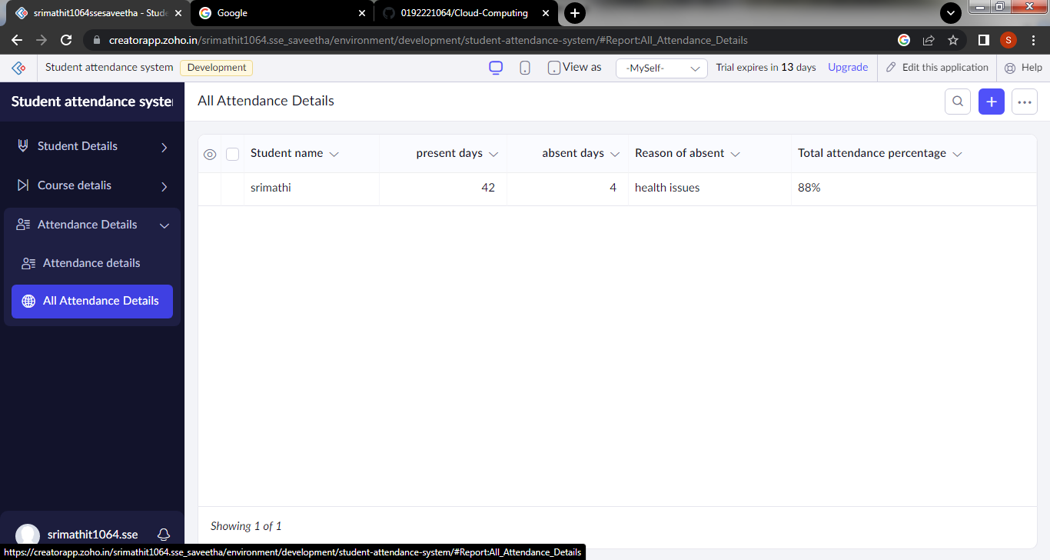

Step 11:click the mobile icon to view the output in mobile form

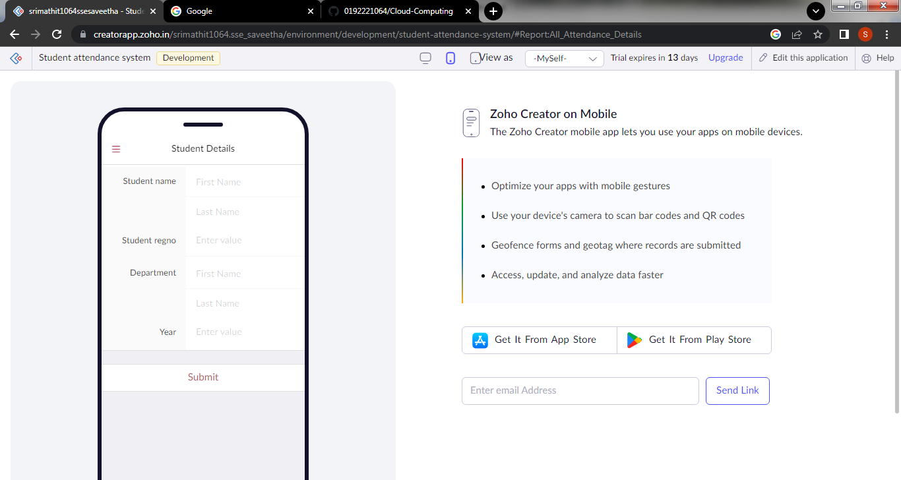

Step 12: click the tablet icon to view the output in tablet form

